**LAPORAN TUGAS PRAKTIKUM**

**PEMROGRAMAN BERORIENTASI OBJEK**

*Laporan ini disusun untuk memenuhi Tugas Mata Kuliah Pemrograman Berorientasi Objek*



Disusun Oleh :

Benny Yoga Suhardi 211511035

**PROGRAM STUDI D3 TEKNIK INFORMATIKA**

**JURUSAN TEKNIK KOMPUTER DAN INFORMATIKA**

**POLITEKNIK NEGERI BANDUNG**

**TAHUN 2022**

**Task 1**

Class Circle

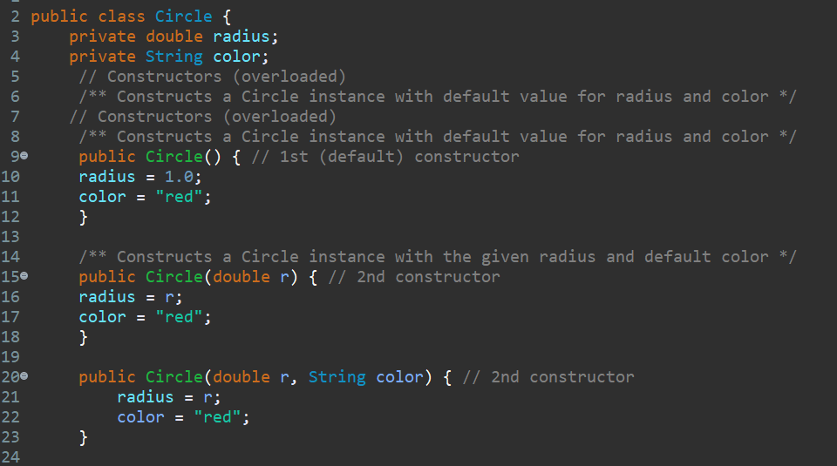

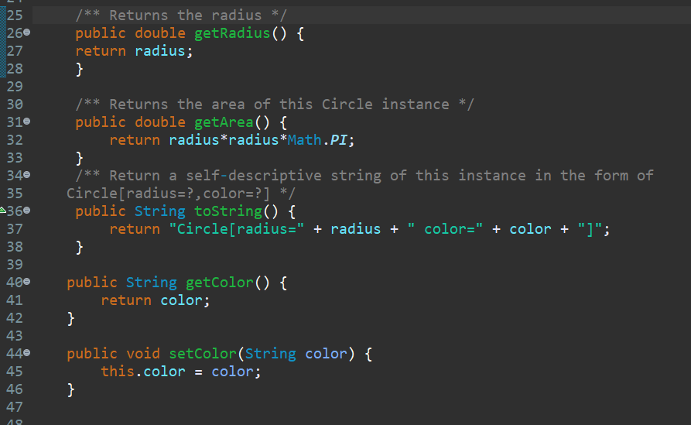

Class Cylinder extend Circle

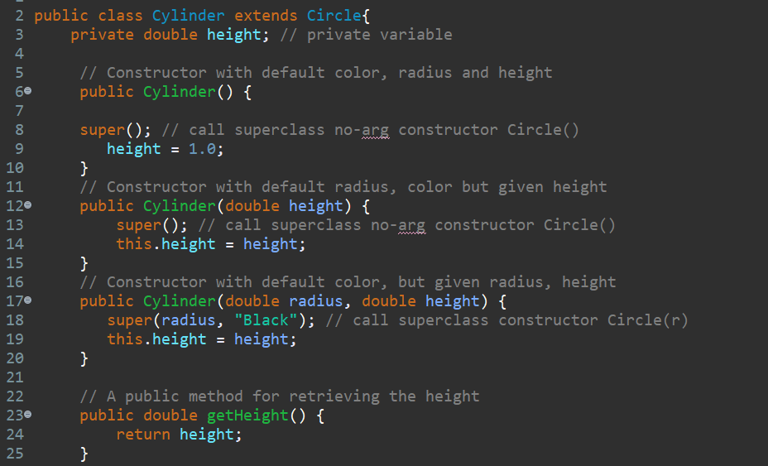

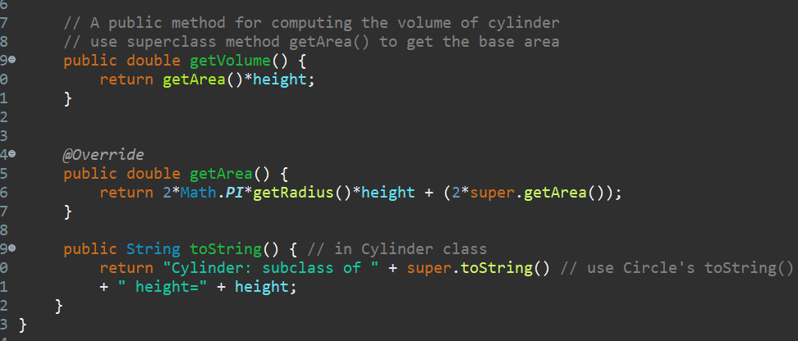

Main Class

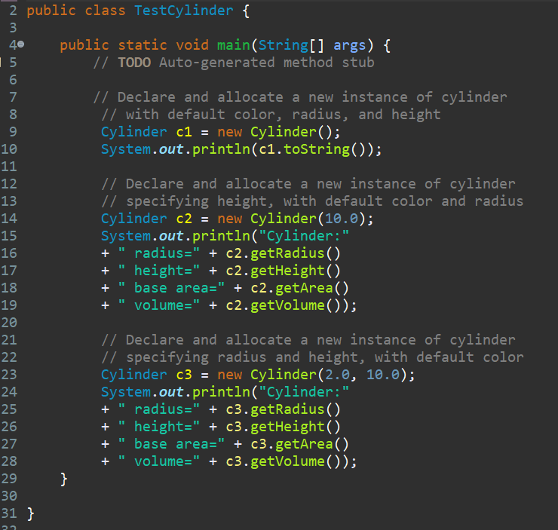

**Result**

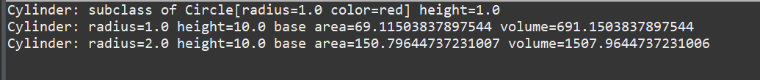

Task 1.1 (Modify Circle Class)

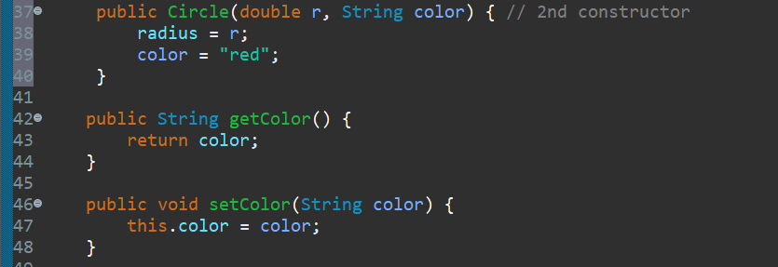

Task 1.2 (Overriding GetArea)

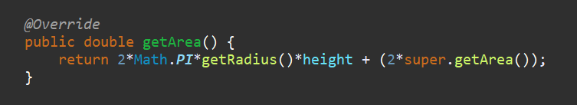

Task 1.3 Provide toString() method

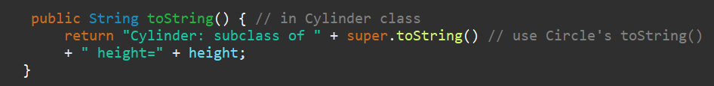

**Task 2**

Class Shape

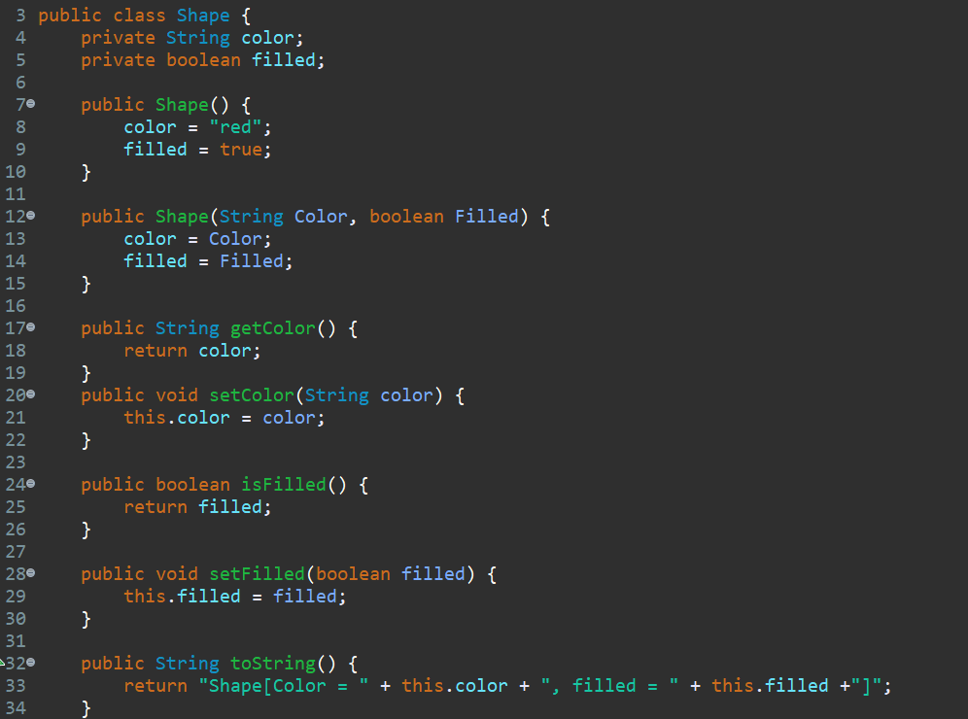

Class Circle extends Shape

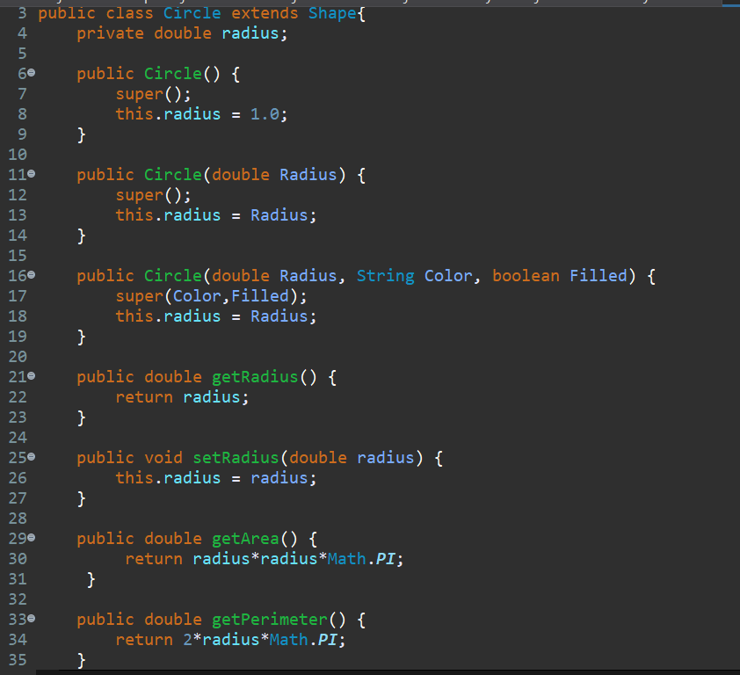

Class Rectangle Extend Shape

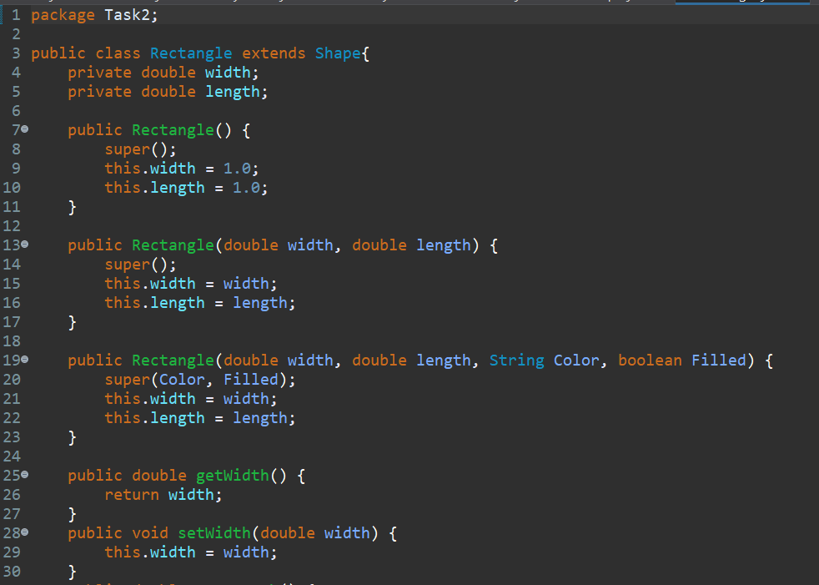

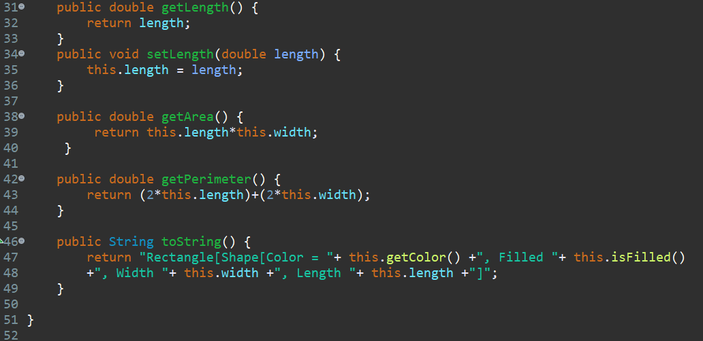

Class Square Extend Rectangle

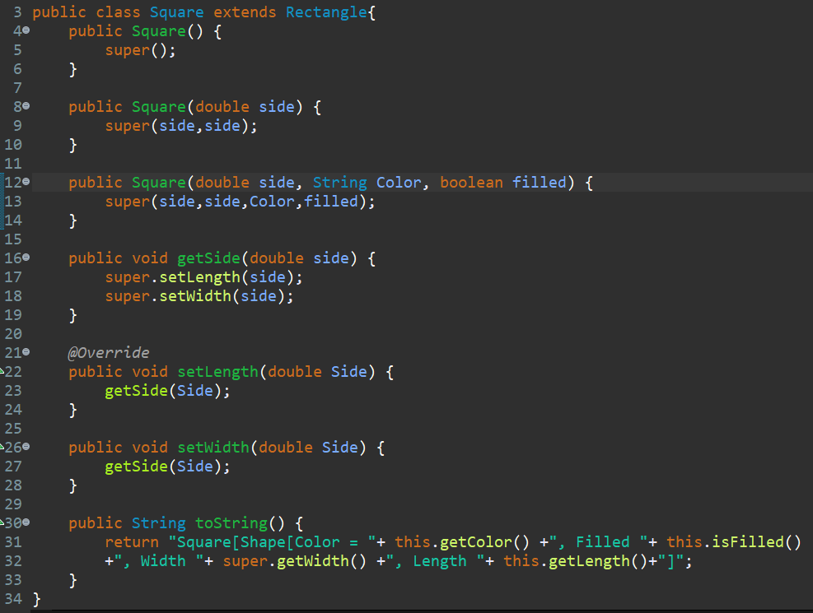

Main Class

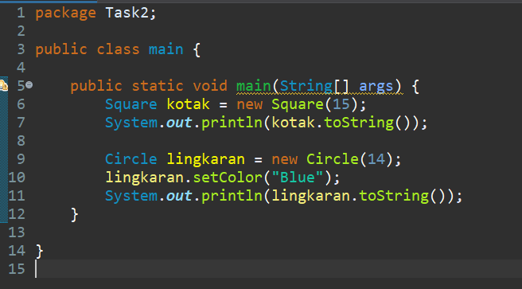

Result

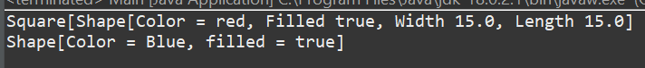

**Task 3**

Class Employee

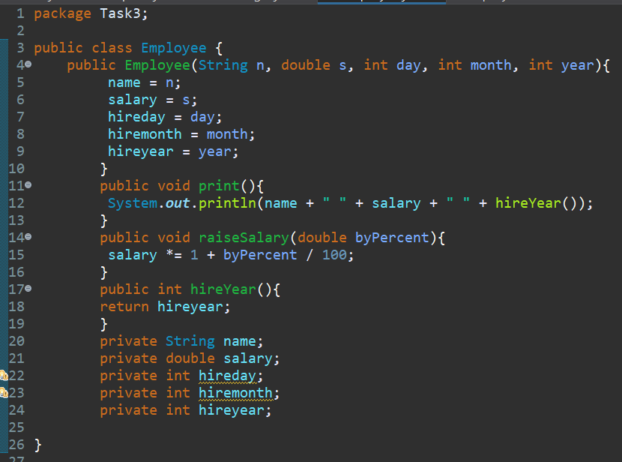

Class EmployeeTest

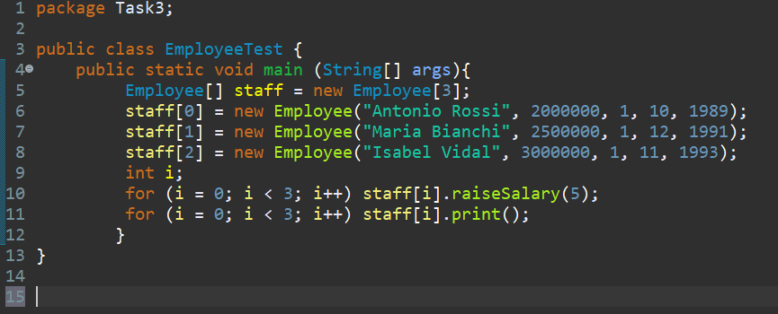

Result

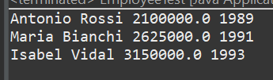

Class Manager

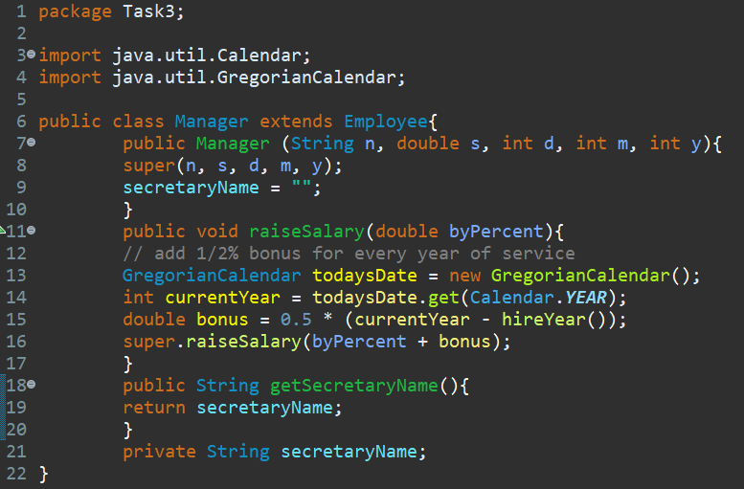

Class ManagerTest

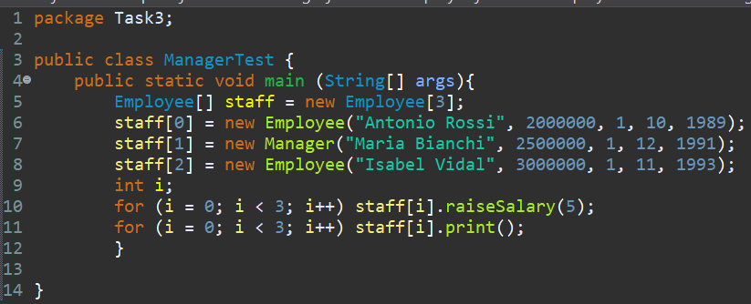

Result

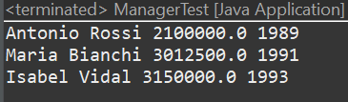

Case 1 (adding ShellSort)

Class ShellShort

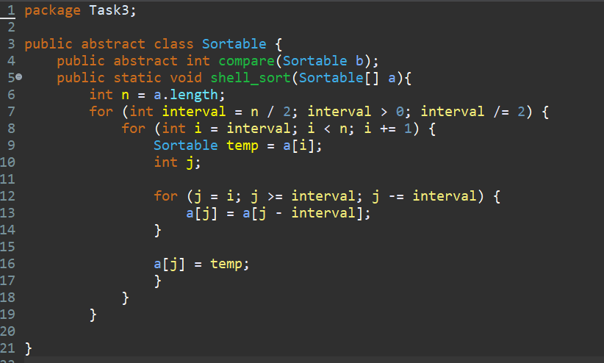

Main Program

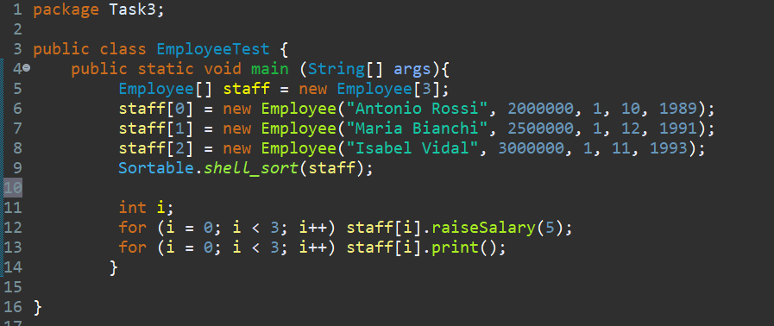

Result With ShellSort

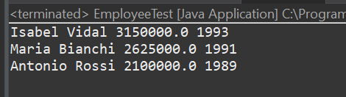

**Link Github :** [BennyYoga/PBO_Praktikum (github.com)](https://github.com/BennyYoga/PBO_Praktikum)